**HOT1 (15%)**

**RULES:**

1. **Open-book** test (You are allowed to refer to any books, notes, and online resources)
2. Accomplish the question individually. You are **NOT ALLOWED** to discuss with your classmates and use any tools to exchange or transfer answer.
3. Test time: 4PM--5:50PM, 21 OCT, 2013.
4. Create a **new** **web site** (Don’t create project) named **YourStudentID** and add three web form pages for this web site to solve the following three questions. These three web pages are named “Q1.aspx”, “Q2.aspx”, and “Q3.aspx”, respectively.
5. Compress the file folder of this web site to one file named **YourStudentID.zip** and submit it in Moodle **before 5:50PM** (Your submission will be rejected after 5:50PM).
6. **Collect user input**

Create a form as shown in the following picture, through which the user can input and submit data. Name your web page “Q1.aspx”.

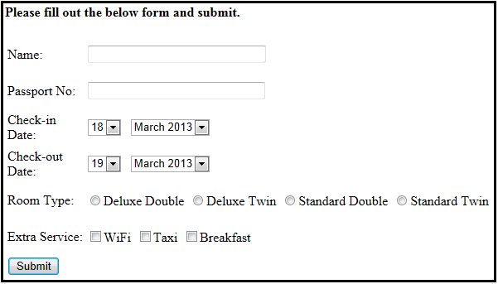

After user inputs data and clicks the Submit button, the summary of the user input is displayed below the Submit button. For example, suppose user input the following data:

Name: **Qin**

Passport No: **G7777777**

Check-in Date: **21 Oct 2013**

Check-out Date: **23 Oct 2013**

Room Type: **Deluxe Twin**

Extra Service: **WiFi, Breakfast**

The summary would be:

**Hello, Qin, please confirm your information:**

**Your Passport No is G7777777,**

**You will check in on 21 Oct 2013 and check out on 23 Oct 2013,**

**You selected Deluxe Twin room,**

**You need extra service WiFi and Breakfast.**

1. **Multiplication Table**

Dynamically display a multiplication table as shown in the following picture. After user selects the rows number from a dropdown list, a multiplication table with the selected rows number is displayed below. The dropdown list has values from 1 to 9. Name your web page “Q2.aspx”.

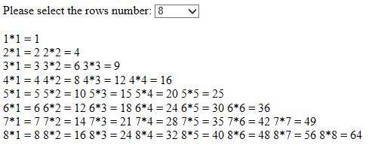

1. **Colorful Multiplication Table**

Based on above question, dynamically display a colorful multiplication table as shown in the following picture. That is, each row has different color. Name your web page “Q3.aspx”.

